***El Deafo***

**Book Club Events**

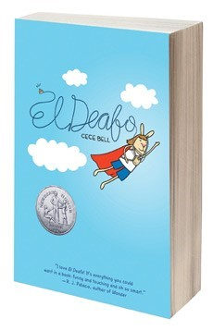

**EVENT**

**DATE & TIME**

**LOCATION**

**DESCRIPTION**

What

’

s Your Superpower?

10

/

13

4:15

-

5:30

Drew

’

s

EA Media Center

What superpower would you like to have? How

would you use your new power? Students will ex-

plore what it would be like to be a Super Hero for

the day!

Become a Graphic Novelist

20

10

/

4:15

-

5:30

Drew

’

s

EA Media Center

Do you like comic books? Do you like to tell stories?

Learn how to combine your love of comics with sto-

rytelling in this hands on workshop.

Be a True Friend Challenge

27

/

10

4:15

-

5:30

Drew

’

s

EA Media Center

In El Deafo, Cece searches for a friend who will ac-

cept her for who she really is. Inspired by her story,

we are exploring ways to be a good friend with the

help of the Senior Academy

’

s No Place for Hate Club!

Deaf Awareness Workshop

11

/

3

4:15

-

5:30

Drew

’

s

EA Media Center

In this workshop, participants will explore what it is

like to be deaf. Through a host of activities, students

will explore how life would be different.

Author Visit

/

6

11

7:00

6:00)

(

Doors open at

Drew

’

s Upper Campus

Auditorium

It

’

s the moment you

’

ve all been waiting for! You

don

’

t want to miss this special celebration, complete

with performances, art, and, of course, a reading

and signing with the author. This event will be first

come, first seated.

**Use the following link to register your child for the sessions and to sign up to volunteer.**

**http://www.signupgenius.com/go/30e0c4aaeab2da5fa7**

**-**

**book**